1. Consider AVL trees.
a) Draw an AVL tree topology of height h=4 with minimum number of nodes N(4)! Note that the height of a single-node AVL tree is h=0 (i.e., N(0)=1)!

b) How many nodes does the above AVL tree have (i.e., N(4)=?)?

c) Is there a different AVL tree topology of height 4 with the same number of nodes?

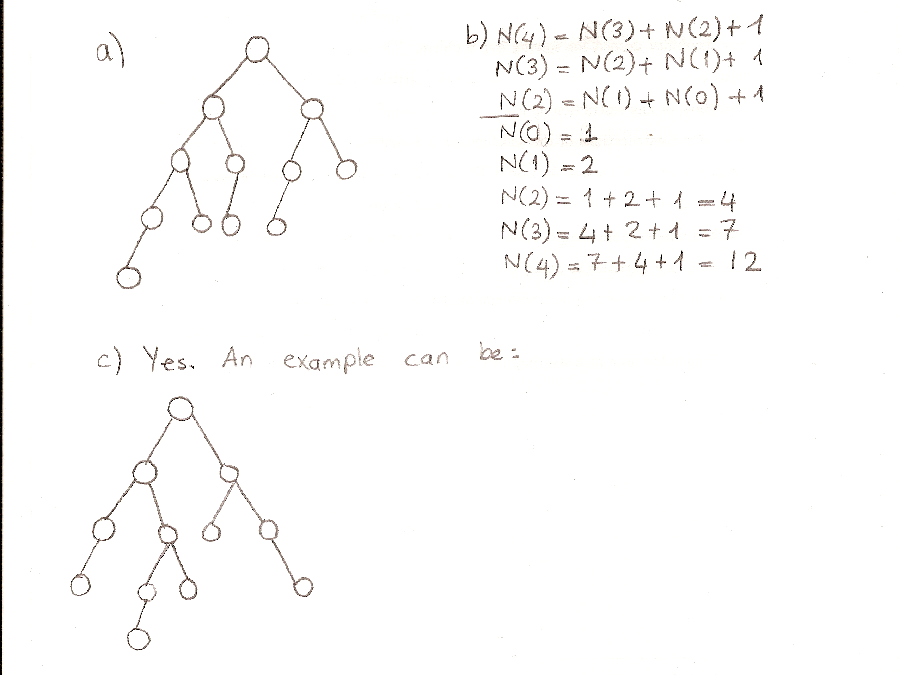

2. A hash table with hash function h(k)=k mod m uses double hashing strategy to resolve collisions. The keys 612 and 1167 produce the hash values 3 and 7 respectively.

- What is the prime hash table size?
- The next key (i.e. the 3rd key) that is hashed to the table after two collisions (each collision with a different key) is 525.
  - What is R in double hash function?
  - Where is 525 hashed in the table?

